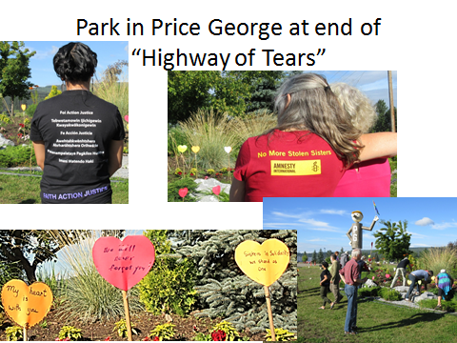**Activists from the “Rolling Justice Bus” gather to remember and honour women and girls who have been killed and disappeared on Highway 17 in northern British Columbia. July, 2016**

